A Limited Team Adventure
Anthony Alongi
Picking up from yesterday...
BUDDE. MOSHOWITZ. WISE. ALONGI?
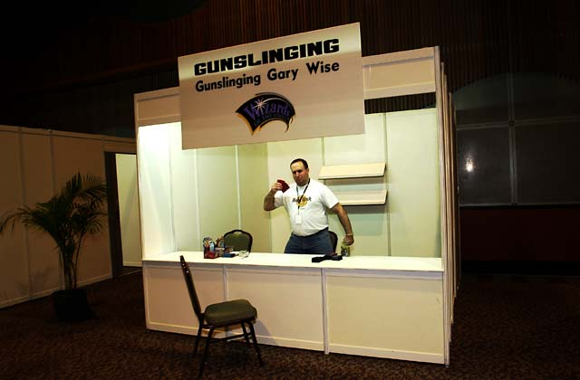
Gary Wise in his gunslinging shack
At about 2 pm on Sunday, feeling a bit wistful, staring at the clock, and wondering when the earliest possible moment would be where I could convince my teammates we should head for the airport, fellow Sideboard writer Gary Wise approached me. Well, actually, he called out to me, really loudly, from about fifty yards away. (Does this surprise anyone?)
Being as distracted as I was, I didn't hear exactly what he says. I hear "practice Rochester draft", "a bunch of us", and "maybe you could write it up for the Sideboard?" I figure heck, sure, I've got a little time, whoever Gary's drafting with, it should be entertaining. I'll watch and write that up.
So I get to the table, and Scott Johns is there, and we trade some small talk, and then he asks me, "so, are you drafting too?" And this makes me stop and pause. I mean, it's possible that Gary had asked me to draft while I was absorbed in my own self-pity a few moments earlier; but I simply couldn't remember his exact words. I look around for a visual signal from Gary; but he's at the other end of the hall, pulling other people in. So I think to myself... if I say yes, and then the invite isn't there, I look like an arrogant idiot...but if I say no, and the invite was there, I'll have blown a chance to draft with two cool cats. So I opt for the truth, which is, "I don't know. Gary asked me to come over here, and I don't know if it's for drafting or writing or both; but I'm here and available."
Then a few other guys walk up. Like Kai Budde. And now I'm thinking to myself, okay, well, I'm glad I didn't say I was drafting at this table, because I'd feel really foolish right now.
Gary walks up as Scott passes out random seat order cards. "Okay, we've got one, two, three, four, five, six, seven -" and at seven, he was pointing to me - "eight."
Scott offers me a choice of seating cards. I pull and reveal: seat eight. Hmmm. I sit down. Here is the table, in seating order:
1. Gary Wise
2. Zvi Moshowitz
3. Brian Kibler
4. Patrick Mello
5. Phil Freneau
6. Scott Johns
7. Kai Budde
8. Anthony Alongi
Quick quiz for you all: How many current-year Pro points are sitting at this table?
150?
200?
250?
300?
According to the back of my envelope on the plane ride home, last guess wins. (I came up with 296, though I was using a copy of Sideboard magazine, and not the latest net rankings.)
Okay, next part of the quiz: how many of these points does Anthony contribute?
25?
10?
2?
0?
Again, last guess wins.
This draft was just another practice Rochester for these guys; but for me it was quite a thrill. I mean, how many guys who have never made the Pro Tour get to read draft signals from Kai Budde? Everyone at the table was a lot of fun; and I didn't get any sense that they resented having an amateur around who might kind of screw up a pick here and there.
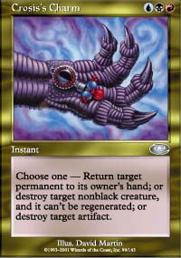
As it turns out, I think I drafted just fine. Red-black was a clear choice early, and I stayed out of everyone's way pretty easily. Gary only felt compelled to point out two errors on my part: I chose a Firescreamer over a Kavu Aggressor (the Aggressor is cheaper and a more consistent 3-power... and I already had one Firescreamer), and a Nightscape Battlemage over Crosis's Charm (the Charm is more flexible, and I was low on removal). Both mistakes were at least within colors; so I'm confident that the more seasoned players still got a worthwhile practice out of it all.
My good teammate Todd, never one to pass an opportunity to let me know where I've screwed up, used his considerable experience in drafting between Gary and Kai to suggest the following later on:
"I personally think your time to "strike" was when you opened your pack of Invasion and saw Teferi's Moat, Angel of Mercy, Faerie Squadron, and a Shivan Zombie. (You took the Zombie.) White makes a nice splash in a b-r deck and Gary Wise would not have minded you taking the Angel of Mercy from him. Just my two cents. You would have set yourself up for some nice r-w or b-w in Apocalypse."
He could be right. I felt Invasion was a bit early to think of Apocalypse, and the Zombie filled a critical two-slot for me; but I can certainly see the opportunity there, in a pack full of blue-white goodness, to take a little bit for myself.
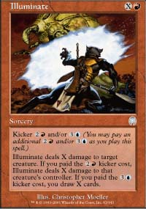 | 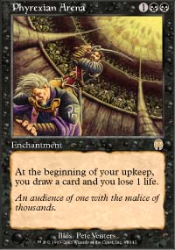
Which one do you take?
I only took one moment, late in the draft, to exploit my amateur status. In one of the last Apocalypse packs, faced with a choice of Illuminate and Phyrexian Arena (but fairly certain the "X-spell" rule was in effect), I asked the whole table what I should take. They unanimously agreed that the X-spell trumped the cantrip machine.
Decks went to the winner of each match and I didn't have time to write down the full decklist I drafted before I lost it. I got few removal cards but some quality, including a Terminate, Exotic Curse, and of course the Illuminate. My creatures were decent - Rogue Kavu, Shivan Zombie, two (oops) Firescreamers, and the Nightscape Battlemage. (I did have a couple of islands, and a Tundra Kavu, to help with the kickers on the Battlemage and Illuminate.) A decent deck, nothing spectacular, nothing horrifying.
As for the table, here's how it panned out:
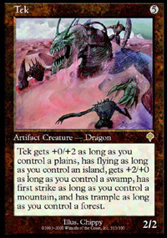
1. Gary Wise: got a great first pick Tek, settled into blue-white as Zvi focused on early green to his left and I had clear red-black on his right. Midway through Planeshift, he picked up a Gerrard's Command, which I took as a signal that he might flirt with blue-green, come Apocalypse. He did indeed take some of that to round out his deck.
2. Zvi Moshowitz: admitted later that he took early green - an Explosive Growth over a Tribal Flames and Duskwalker - in an attempt to shake Kibler out of his favorite color. Ended up with a solid 5c deck, with primary focus on the red-green-white axis.
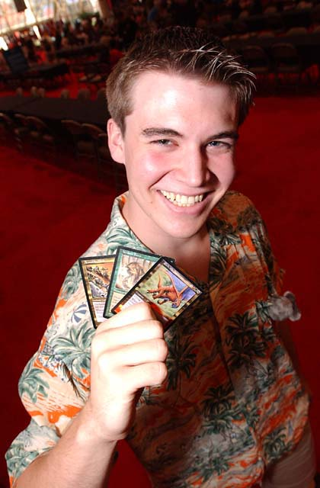
3. Brian Kibler: laughed a lot during the draft, and picked more non-basic lands at the mid-range slots than seemed completely healthy to my less-tested eyes. He was fighting with Patrick to his left for red and black (scoring a Tribal Flames, Nightscape Master, and other cards that would have helped Patrick a lot); and with Gary, Phil, and even Zvi capable of taking decent blue picks from him, I'd say he was truly squeezed.
4. Patrick Mello: red-black, all the way. Seeing him take early red-black, even when fighting with Brian, made me more confident in doing so, since by the third or fourth pack I felt I could depend on good red-black to cross nearly half the table.
5. Phil Freneau: I felt Phil had the best deck by draft's end. He went early blue-white with strong flying creatures, and then Apocalypse just fell in love with him: a Raka Sanctuary and at least two Jilts. I couldn't stay long enough to watch the other matches, but I would not be shocked to hear that Phil won the whole enchilada.
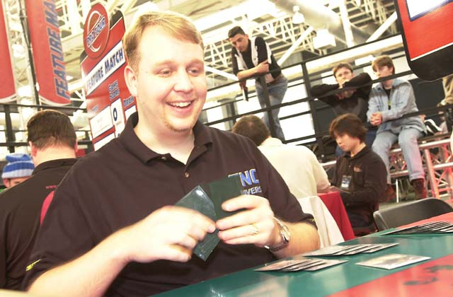
6. Scott Johns: Honestly, I was trying to do so much at the table - report, draft, ask Gary his opinion on other players' picks, crack the occasional joke about chaos format - that I didn't completely see the picks Scott made. But he definitely had base green, and went at least three colors, possibly four (white-red-green, maybe black). He swiped a Vicious Kavu from me, so I reinforced my vow never to write for that hack site Mindripper.
7. Kai Budde: I think next to Brian, Kai had the hardest draft, since his natural choice, blue-white, was getting lightly squeezed from two to the left and two to the right, with Scott taking several good white cards at his right. He did settle into blue-white, with the occasional late black pick. Kai sent crystal-clear signals, and I hope I did them justice.
8. Anthony Alongi: Red-black, as noted above.
Matches were randomly selected; I got Zvi. I don't want to hear any crap from anyone, ever again, about how they got "paired up".

If I lose, people will expect it. If I win, this will make for the most amazing article ever. And I will be able to say I am undefeated in matches against Zvi Moshowitz...
While I had met Zvi briefly while reporting for Pro Tour -Chicago and Pro Tour-Los Angeles last year, this was the first time that the Pro Tour-Tokyo Champion and I got to chat for a bit. He's a friendly guy with a streak: he had drafted Explosive Growth ahead of some terrific Invasion cards, simply to push Brian Kibler out of green (where Zvi felt Brian would be most comfortable). He ended up 5c green, which ought to be a decent match-up for a fast enough red-black deck. So I wasn't going to be able to blame this on the deck matchup.
I draw seven, see two swamps and five red cards. Now being something of an unsuccessful but still noted intellectual on Limited formats, I realized I could not keep this hand against a player of Zvi's caliber. According to the percentages, I would be giving him about one and a half free turns. So I mulligan. (And when I explained this to him later, he agreed it was the right move.)
No land.
I sigh a bit, knowing immediately that I must go down to five. And so I do.
No land.
Now I'm getting ticked off. I don't mind losing to someone like Zvi because of a disparity of raw skill at the game; but there are 17 lands in this deck, the curve of the deck is fairly low, the color requirements for red and black are split evenly, so is the basic land... I shouldn't even be suffering from color screw, much less mana screw. But I have no choice. I have to go down to four. (Again, Zvi confirmed in retrospect. I'm not an idiot; I did use this excellent opportunity to ask about and refine my strategies in drafting, mulliganing, playing, and every other aspect of the game I could get these guys to comment on.)
No land.
This is, of course, the inflection point where you just take it in the groin and say, "whatever. I'm playing the Pro Tour-Tokyo Champion, and giving him a three card advantage... four, if you count the fact that I'm going first. If I lose, people will expect it. If I win, this will make for the most amazing article ever. And I will be able to say I am undefeated in matches against Zvi Moshowitz."
Of course, none of that happened. Zvi went aggro on me with a Sunscape Apprentice (I think... my memory is rather hazy through the filter of my re-simmering fury) and it was all downhill from there.
Game two, at least I got to lose more conventionally. I kept a hand with even mana and good early cards. I played out a Bloodfire Dwarf and Rogue Kavu (and before you all giggle about the non-synergy out there, I'll have you know these were two of only three one-toughness creatures in my deck), and then watched Zvi thunk down a Lashknife Barrier.
My Dwarf pretty much regressed into a fetal position at that point, and as Zvi put out 5c gems like Nomadic Elf and Horned Kavu, I contemplated playing the Illuminate in my hand without either kicker. I eventually had to, and while I've played with and against Lashknife Barrier numerous times in both multiplayer and Limited settings, Zvi actually had to remind me to cast it for X=5 on a four-toughness creature. That pretty much tore it for me: the least I could have done is avoided a ridiculous play error. You play the game for three years, you don't make mistakes like that unless you're off your game. A sunken Grand Prix, a mediocre PTQ, and a triple-mulligan experience into this weekend, I was so far off my game, I'm fairly certain I had collapsed onto someone else's game. That someone else was, I suspect, pretty awful at Magic.
I'm sounding pretty down now; but honestly, I feel great about the weekend! I want readers to hear this again: the weekend, the qualifier, the mediocre record, the lack of food after 3:00 pm: it's all still worth the work and effort. If you're thinking about doing something like Grand Prix-Columbus as a team next year... DO it.

You don't raise your level of play until you do these kinds of events...
I'll start by ticking off the benefits as an individual. The practice Rochester draft was, hands down, my favorite moment in my Magic career not involving a Grave Pact and six other players. (And I'll admit this isn't the most transferable reason to sell going to a team Grand Prix; but keep reading; there's more.) I went a nice 5-2 over a stretch covering the Grand Prix trial and the first half of Day 1. And whether winning or losing, our team was meeting great people from all around the world with a common love of the game and interesting perspectives on strategy. And I exposed myself to a new format, IBC, which I'll just have to tinker with now. (Do I smell a new Sideboard series?)
I also got to meet most of the rest of the internet writer-player community that I hadn't met yet - Nate Heiss, Seth Burn, Kurt Hahn, and John Rizzo were all fun to chat with for the first time, even if it was just briefly.
As for team Mom Has the Kids... Again, playing under these circumstances, with players at this range of levels, was a critical experience for the three of us. You don't raise your level of play until you do these kinds of events, and the first time can entail a bit of system shock. (The way I think about it is, the first time I went to a PTQ, I had three match losses. The second time, I went 5-1-1, and made Top 4 in the draft. This first Grand Prix, we had three match losses...) We watched a few teams sporting one or more pro players get questionable card pools, and wither and die a couple of rounds before we did. Todd and Bob could snicker at my ill fate during my match with Zvi. They posted decent records at side drafts. And we all three had a great time; because we're friends and a trip with "just the guys" did our fatherly hearts some good.
And all in all, I'd say we have a good foundation to build on for next year, if we decide we want to go through all of this again.

SLOPPY PROPS
So that brings me to the end, and my thank-you list, which I have considered completely. If you're not on this list, rest assured I have thought about you directly but decided you are unworthy of mention below. I'm a big-shot Grand Prix player; and with my lifetime record at big events threatening to bust past .500, I just can't afford to remember all the little people anymore.
First, thanks to Gary Wise for that terrific invite to Rochester draft. And to the other six luminaries at the table that day, thank you as well for giving the impression, for a little while, that I belonged there. If any of you are at Grand Prix-Minneapolis, we'll have to do it again... except this time, we play an eight-player chaos when the draft is done!
Thanks to all of the players who came up to me during the weekend and told me nice things about my writing, especially this series. Our team put a lot of work into getting this information out here; and while we couldn't demonstrate our increased knowledge the way I had hoped, it did our hearts tremendous good to see that people felt better prepared from reading the stuff. We wanted this to help others, not just ourselves. And we're glad it did.
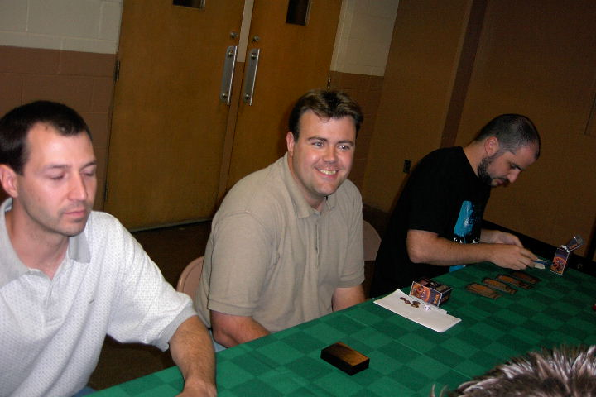
Thanks to my teammates, Todd Petit and Robert Drosky, for helping me with these articles, and for throwing their matches during the Columbus trial so I wouldn't have to be the one to sleep on the cot.
Thanks to our casual play group. Everyone, I hope I have made it clear in past articles that I play among some of the most creative and analytic minds you can find. Without the constant exposure to fun and good ideas I get from our regulars - Anthony Davis, Curt Jorenby, Don Musch, Paul Hemze, Robert Jungbauer, George Maverick, and Joe Santos - it just wouldn't be fun at all. And I wouldn't make certain connections that have helped me in tournament play. And I wouldn't be writing about Magic of any kind - which worst of all, means people would actually be looking to The Ferrett for multiplayer strategy.
Thanks to Team Flying Red Car, Team Monster Rod, whatever Team Monster Rod's successor got called, and all the other teams and players who played against us, practiced alongside us, and laughed with us. A good time, with good people.
Thanks to my older brother Daniel, who during our youth gave me the valuable experience getting the tar knocked out of me that I needed to handle the larger part of this experience with equanimity.
Thanks to Omeed Dariani and the rest of the Sideboard/Wizards folks, for giving this series the green light. It was a fun assignment, and an opportunity to demonstrate a little range beyond my usual fare.
Thanks to John Rizzo for not taking off his shirt when he met me, and for not screaming "BLASPHEMER!" when I told him I was dropping out of the qualifier after four rounds.
Thanks to Chris Cornell, who is now in collaboration with Rage Against the Machine, for saving me from buying two CDs a year in the future, when now I'll just have to buy one.
Lastly and most importantly, thanks to Angie, MaryJanice, and Tracy; and to Christina, Connor, Daniel, Helen, Liam, Matthew, and Thomas; for letting us go on Friday, and for taking us back in on Sunday. It feels good for Dad to have the kids... again.

